**Django Encrypted Chat Application Roadmap**

**And Documentation**

**Phase 1: Project Setup and Basic Structure**

1. **Environment Setup**
   * Python and Django installation (Core web framework

-Version: 5.0)

* + Virtual environment creation
  + Initial dependencies (Django, Channels, Cryptography)

The pip keyword stands for **"Pip Installs Packages"**. It is a package management system for installing and managing Python libraries or dependencies.

- **Django**: This is the core framework of the project. It handles the basic structure and functionality of the web application. **You can install it by running “pip install django”.**

- **Channels**: Django Channels extends Django to handle WebSockets, HTTP2, and background tasks. This allows for asynchronous communication in Django, enabling real-time functionality such as live chat, notifications, and other WebSocket-based interactions. **Installation “pip install channels”.**

**-** **Cryptography:** Cryptography is a package that provides robust cryptographic recipes and primitives to Python developers. It includes tools for encryption, hashing, signing, and other security-related operations. **Installation “pip install cryptography”**

**Dependencies installed:**

1. **Django –** Core Web Framework
2. **Django Channels -** Purpose: WebSocket support**,** Will enable real-time chat functionality, Required for async communication.
3. **django-htmx -** Purpose: AJAX functionality without writing JavaScript, Used in our chat interface for dynamic updates, Enables partial page updates for better user experience, Integrated in base.html: <script src="https://unpkg.com/htmx.org@2.0.2"></script>
4. **django-allauth** - Authentication system, Handles user registration, login, logout, Manages user sessions and security
5. **django-cleanup -** Automatically handles file cleanup, Deletes files when FileField/ImageField is changed/deleted, Helps manage media files efficiently
6. **Pillow -** Python Imaging Library Handles image processing, Required for Image Field in Django models, Used for profile pictures/attachments.
7. **Cryptography –** For Encrypting data.
8. **Project Architecture**

**Created App1 (Frontend/Main) with structure:**

1. a_core (Main project settings)

* Project settings
* Main URL configurations
* ASGI/WSGI configurations
* Base settings.py file

1. a_rtchat (Chat application)

* Main chat application
* Contains models: ChatGroup, GroupMessage
* Views for chat functionality
* Templates for chat interface
* WebSocket consumers (to be implemented)

1. a_users (User management)

* User management app
* Profile models and views
* Authentication templates
* User-related functionality

1. a_home (Landing pages)

* Landing pages
* Static pages
* Welcome/introduction views

**Created App2 (Backend/Storage)**

1. ab_core (Backend API and storage)

* Message storage API
* Database operations
* Backend services
* API endpoints

**Phase 2: Authentication System**

1. User Management
   * Install django-allauth
   * Configure email authentication
   * Create login/signup templates
   * User profile setup
2. Authentication Views
   * Login view
   * Registration view
   * Profile management
   * Password reset functionality

**Phase 3: Basic Chat Functionality**

1. Database Models
   * ChatGroup model
   * GroupMessage model
   * User relationships
2. Chat Interface
   * Chat room template
   * Message display
   * Message input form
   * Basic styling (CSS)

**Phase 4: Real-time Communication**

1. **WebSocket Setup**
   * Install Django Channels

In this part we use the **DAPHNE** as a server for our application. Daphne is an HTTP, HTTP2, and WebSocket protocol server for Django Channels. It is the default server used to run Django applications that require asynchronous communication, particularly when working with Django Channels.

* + Configure ASGI in settings.py file
  + Set up channel layers

1. **WebSocket Implementation**
   * Create Consumers.py
   * Implement connect/disconnect handlers
   * Message handling
   * Group management

**Configure WebSocket settings in settings.py:**

* Add Channels to INSTALLED_APPS
* Configure ASGI application
* Set up channel layers with Redis

**Phase 5: Message Storage System**

1. **Backend API (App2)**
   * Message storage endpoints
   * Message retrieval endpoints
   * API authentication
   * CORS configuration
2. **Frontend-Backend Communication**
   * MessageService implementation
   * API integration
   * Error handling
   * Connection management

**Phase 6: Encryption System**

1. **Encryption Setup**
   * Generate encryption keys
   * Configure Fernet encryption
   * Key storage management

**Missing Dependencies (Need to Add):**

* + Django Channels for **WebSocket** support
  + **Cryptography** library for **Fernet encryption**

**Install remaining core dependencies:**

* pip install channels
* pip install cryptography
* pip install daphne
* pip install redis

1. **Message Encryption**
   * Implement message encryption
   * Implement message decryption
   * Error handling for crypto operations
   * Secure key management

**Phase 7: UI/UX Enhancement**

1. Frontend Improvements
   * Responsive design
   * Real-time message updates
   * Loading states
   * Error notifications
2. User Experience
   * Message timestamps
   * Read receipts
   * Typing indicators

**Phase 8: Testing and Security**

1. Security Measures
   * Input validation
   * XSS protection
   * CSRF protection
   * Rate limiting
2. Testing
   * Unit tests
   * Integration tests
   * WebSocket tests
   * Encryption tests

**Technical Stack**

* Backend:
  + Django 5.0+
  + Django Channels
  + Django REST Framework
  + SQLite/PostgreSQL
* Frontend:
  + HTML/CSS/JavaScript
  + HTMX
  + WebSocket
* Security:
  + django-allauth
  + cryptography
  + Django's security middleware
* Development Tools:
  + Git
  + Virtual Environment
  + VS Code
  + Django Debug Toolbar

**Frontend Libraries (via CDN)**

* + 1. **AlpineJS**

<script src="https://cdn.jsdelivr.net/npm/alpinejs@3.x.x/dist/cdn.min.js"></script>

* + - * Lightweight JavaScript framework
      * Handles dynamic UI interactions
      * Used for reactive data binding
    1. **HTMX**

<script src="https://unpkg.com/htmx.org@2.0.2"></script>

* + - * AJAX functionality
      * Dynamic content loading
      * Real-time updates
    1. **Hyperscript**

<script src="https://unpkg.com/hyperscript.org@0.9.13"></script>

* + - * Small scripting language
      * Enhances HTML with behavior
      * Used for UI interactions
    1. **Tailwind CSS**

<script src="https://cdn.tailwindcss.com"></script>

* Utility-first CSS framework
* Responsive design
* Modern UI components

**Key Features**

1. Real-time Communication
   * WebSocket-based messaging
   * Group chat support
   * Message persistence
2. Security
   * End-to-end encryption
   * Secure authentication
   * Protected API endpoints
3. User Experience
   * Real-time updates
   * Responsive design
   * Error handling
   * Session management

**Key Components Deep Dive**

**Front End Stack:**

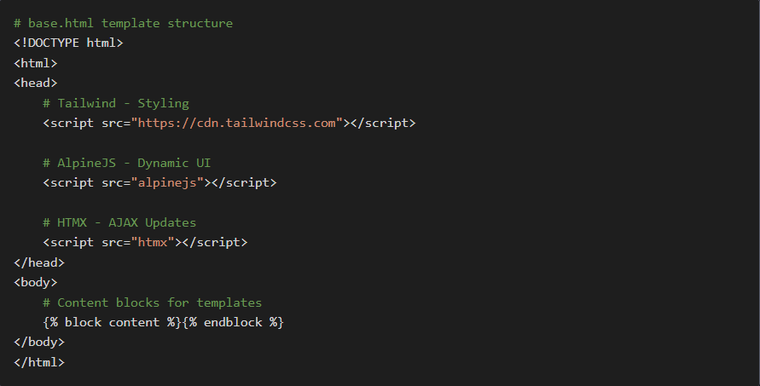

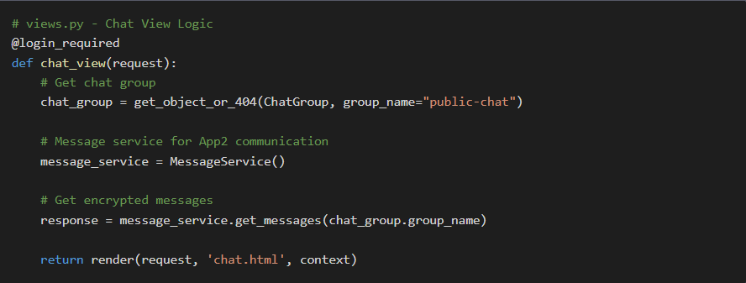 **Backend Structure:**

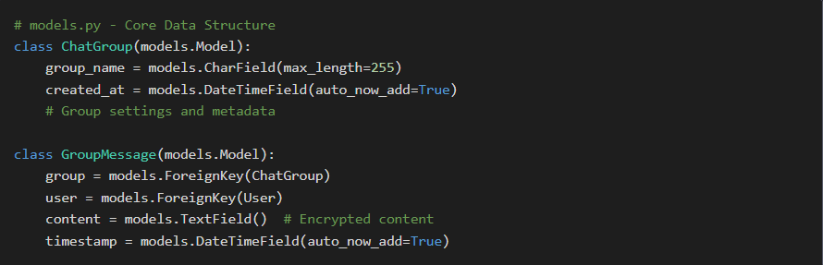**Database Models:**

1. **Security Encryption**

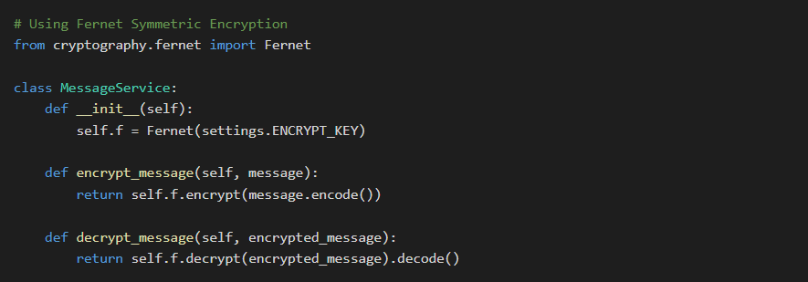**Message Encryption:**

**WebSocket Integration:**

